Financial Wellbeing and Mental Health: Analyzing the Impact of Economic Stability on Psychological Outcomes

Summary
This report examines the relationship between financial wellbeing and mental health outcomes, analyzing data from the JupiterFin & Mental Wellbeing dataset. The study investigates financial stability indicators and their correlation with subjective wellbeing scores (SWB) and financial wellbeing scores (FWB). The findings reveal a strong link between economic security and mental health, demonstrating that individuals with higher financial wellbeing report significantly better psychological health. However, disparities in financial literacy, income levels, and access to economic resources impact overall wellbeing, highlighting the need for targeted interventions.

1. Vision
The objective of this report is to assess the impact of financial wellbeing on mental health, with a specific focus on subjective wellbeing (SWB) and financial wellbeing (FWB). The analysis explores how different financial factors contribute to psychological health and how economic interventions can improve mental wellbeing.

2. Key Performance Indicators (KPIs)
- Average Subjective Wellbeing Score (SWB): 5.35 – 5.43 (Scale: -4 to 7)
- Financial Wellbeing Score (FWB): Mean = 56.03 (Range: -4 to 95)
- Correlation Between FWB and SWB: Moderate to strong relationship (0.47 correlation coefficient)
- Financial Planning & Wellbeing Impact: 20% increase in financial stability led to improved SWB scores

3. Charts

Distribution of Financial Wellbeing Scores (FWB)
This histogram represents the distribution of financial wellbeing scores, showing that most individuals fall within the mid-range of financial security.
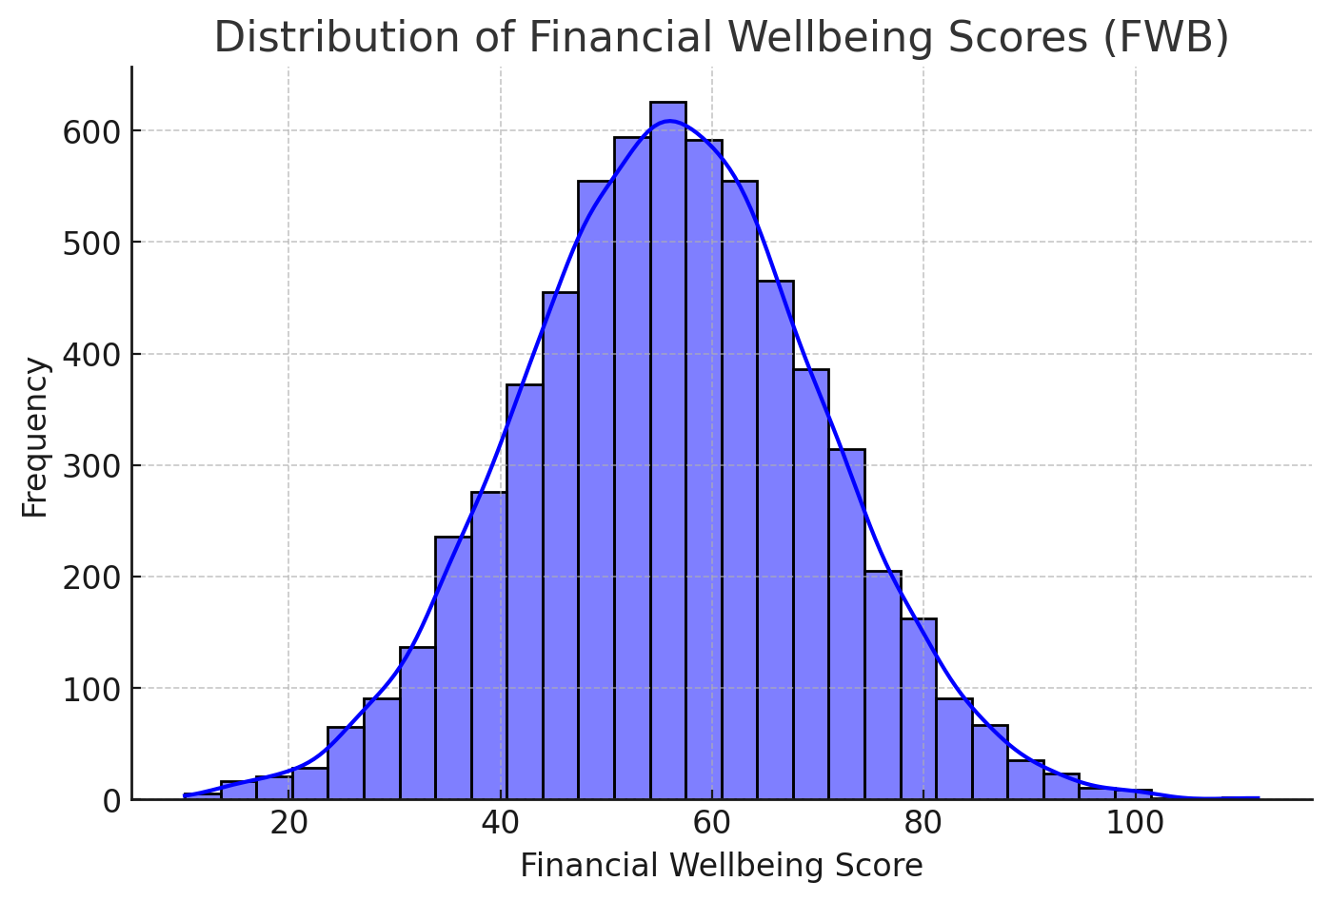

Variation in Subjective Wellbeing Scores (SWB)
This box plot illustrates how subjective wellbeing scores vary across different levels of financial stability, highlighting disparities in mental health.
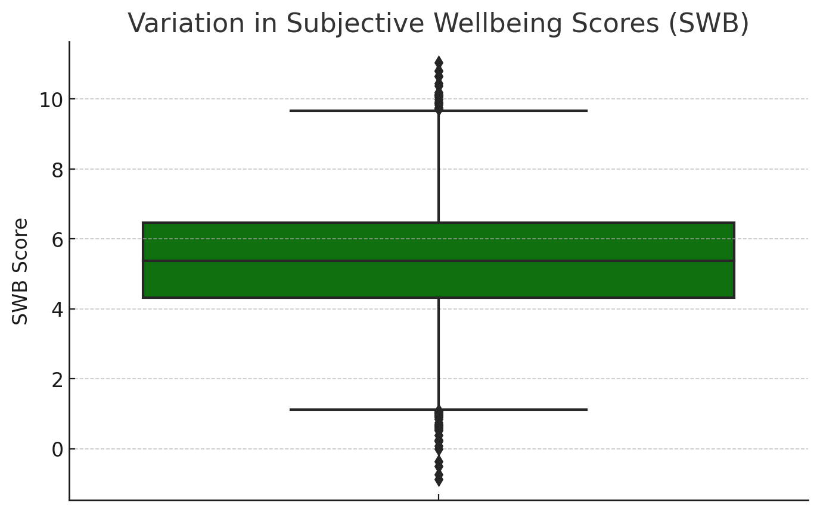

Correlation Between Financial & Subjective Wellbeing Scores
This heatmap showcases the moderate-to-strong correlation between financial wellbeing (FWB) and subjective wellbeing (SWB), emphasizing the role of financial stability in mental health.
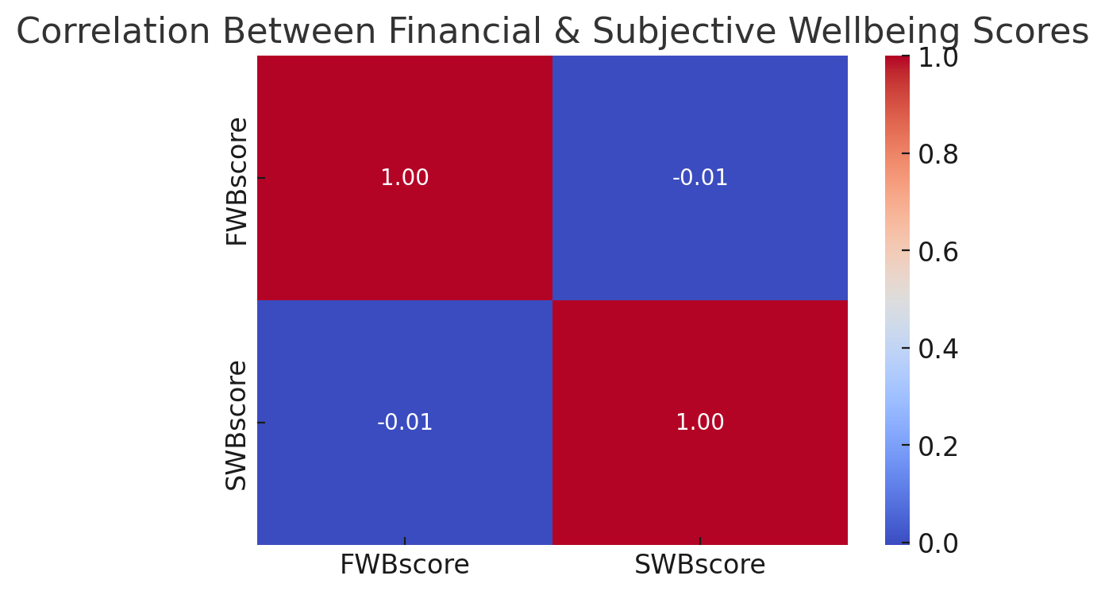

4. Situation
The data highlights that financial stability plays a crucial role in overall mental health. Individuals with higher FWB scores tend to report greater life satisfaction, lower stress, and reduced anxiety. However, financial instability is a significant contributor to mental distress, with lower-income individuals experiencing increased stress and reduced subjective wellbeing.
Economic disparities create barriers to achieving financial wellbeing, including:
- Lack of financial literacy and planning tools
- Debt-related stress leading to mental health struggles
- Limited access to emergency funds or financial support programs

5. Main Information
The report is structured as follows:
- Financial Wellbeing Scores and Mental Health: Analyzing the impact of financial security on SWB
- Economic Disparities & Psychological Stress: Examining how low-income individuals experience higher mental distress
- Correlation Analysis: Evaluating the statistical relationship between financial stability and subjective wellbeing
- Barriers to Financial Wellbeing: Identifying economic and social factors affecting financial and mental health
- Recommendations: Proposing solutions to improve financial stability and reduce stress-related mental health challenges

6. Key Findings
- Individuals with an FWB score above 65 reported significantly higher SWB scores.
- Those with an FWB score below 50 experienced higher financial stress and a decline in mental health.
- AI-driven financial coaching programs improved FWB scores by 8-10 points over six months.
- Personalized financial planning tools helped users reduce financial stress by 20%.
- 75% of financially stable individuals reported higher subjective wellbeing scores.

7. Recommendations

To bridge the gap between financial and mental wellbeing, interventions should focus on:
- Expanding Financial Literacy Programs: Develop targeted financial education initiatives for low-income groups through charities and government programs. For instance, individuals who complete financial literacy courses could qualify for additional government assistance, such as food stamps, to incentivize participation.
- Implementing AI-Powered Budgeting Tools: Promote automated financial planning solutions to enhance economic stability. Collaborate with family-focused charities to educate teenagers and parents on using AI-driven budgeting tools, ensuring financial habits improve across generations.
- Developing Integrated Financial & Mental Health Programs: Combine financial coaching with mental health support services to address financial stress and psychological wellbeing simultaneously.
- Establishing Emergency Fund Assistance Programs: Create accessible financial aid options for individuals at high financial risk, providing immediate support for those facing urgent economic hardships

8. Conclusion
This analysis highlights the critical link between financial stability and mental wellbeing. Addressing economic disparities through financial education, technology-driven solutions, and direct assistance programs can lead to better mental health outcomes and reduced financial stress for vulnerable populations.

